Persistence of Vision Display

Introduce:

Persistence of vision (POV) is a property of the visual system that combines individual visual cues into smooth and seamless images. For this project, our group will develop and implement a POV system powered by a microcontroller that can display words and possibly emoji.

Design graph:

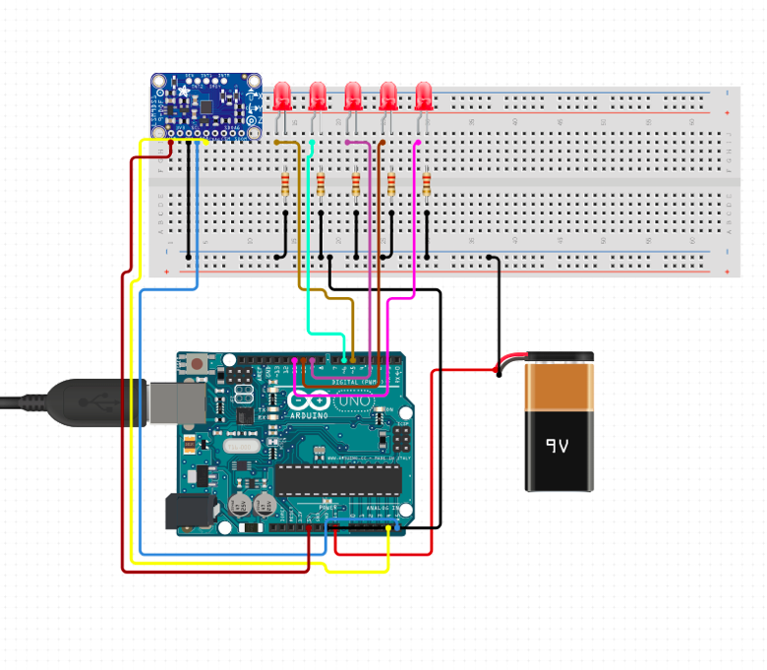

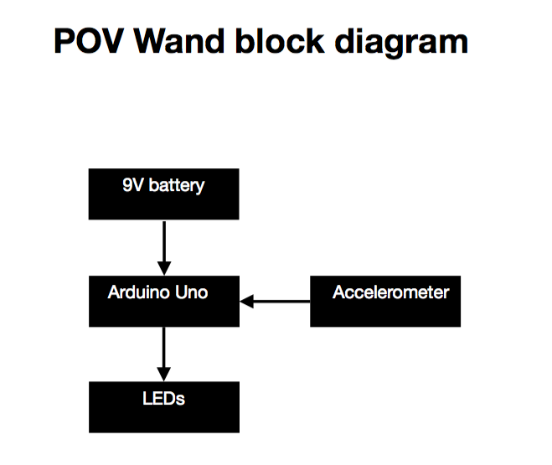

LEDs schematic:

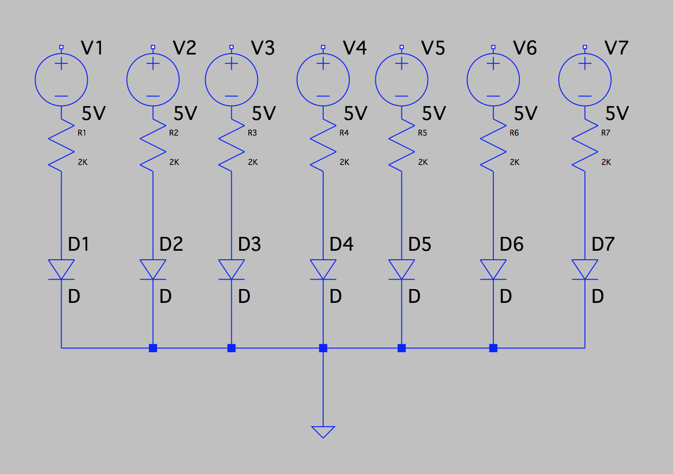

Interface Definition

|  |  |
| --- | --- |
| Name | Properties |
| DC power_to_Microcontroller | Vnominal: 9V  Vo: 5V |
| Microcontroller_to_LEDs | Vnominal: 5V |
| Accelerometer_to_Microcontroller_Comm | Datarate: 9600  Message:acceleration data (m^2)  Protocol: I2C  Vmax: 5V  Vin: 3V  Other: 16 bit data output |
| Outside_envir_to_Accelerometer | Detect acceleration in three axis (X,Y, Z) |
| LEDs_outsider_Usr | Display characters of at least 7X5 pixels |

Code:

Reference:

Accelerometer =>LIS3DH

*UART/Accelerometer connection:

<https://learn.adafruit.com/adafruit-lis3dh-triple-axis-accelerometer-breakout/arduino>

https://www.arduino.cc/en/Tutorial/ADXL3xx

IDEA:

Output from x,y,z. Z gives acceleration and direction. Depending on Z location and speed we can change the rate at which the led will turn on and off.